www.bobhays.com/atari512k.html
How it works...
Well the Atari 800 uses an 8-bit 6502 as it's main processor, so it can only access a total of 64K at one time. Normally in an Atari 800, the lower 48K is RAM ($0000- $BFFF) and the upper 16K is ROM space($C000-$FFFF).
The Atari 800 512K RAM Card uses the second 16K block of memory as a window to thirty two 16K memory banks. This 16K window ($4000-$7FFF) is great to use because it is well above RAM used for Atari OS & DOS and well below the RAM used for screen memory & display lists.
When the Atari 800 is turned on the RAM Bank #31 (0-31) is used as the normal 16K memory board. The other 16K RAM banks can be used for holding DOS menus, RAM Disks, etc...
You can easily select the desired RAM bank by writing any value to ROM memory locations $E000-$E01F (57344-57375 (Dec)). For example to select RAM Bank #2 (Banks # from 0-31) in BASIC then type the command:
Poke 57346,0
The Atari 512K RAM Card uses a 512K Static RAM chip which has a very low-power data retention mode. The on-board Lithium battery (CR2032) will preserve the contents of RAM banks #0-30 when the computer is turned off. The OS wipes RAM bank #31 when the computer starts up, this bank is used to emulate the normal 16K memory board.

Atari 512K RAM Card

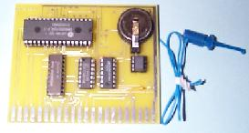

The picture is of the final version of the card. I normally have always wirewrapped first. But I believed it would be quicker in this project to draw it in circuit board design program and then fine tune the first prototype with trace cuts and jumper wires.
The jumper clip wire needs to clip onto a IC pin on the Atari 10K OS ROM Card. (It does not matter whether using Rev A. or B Roms)

Installation

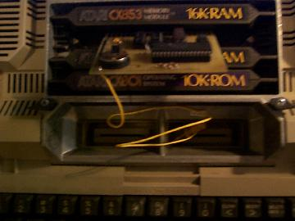
Card installs in 2nd 16K RAM Slot

Installation
It is very easy to install, just pop the top cover lid of the Atari 800.
Remove the 2nd 16K RAM module.
(Note: some later models of the 800 just had circuit boards without plastic covering. This wasn't because of a heat problem, as some speculated, it was a cost cutting move in the price wars with the Commodore 64.)
Insert the Atari 512K RAM Card in the vacated slot.
(The picture in the right is of the prototype of the card being slid in to the proper RAM slot. Notice that the component side is facing the back of the Atari 800.)
Without connecting the jumper wire, this will act as a normal 16K RAM board.

Installation continued...

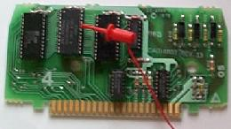
Jumper Wire to OS ROM Card

Remove the Atari 10K OS ROM Card, this is the card closest to the front of the 800. Remove the 2 screws that hold the metal faceplate to the plastic housing. Then pry open the plastic cowling at the bottom and slide the board out.
(Note: some later models of the 800 just had circuit boards without plastic covering. If so, skip this step)
At left, is a picture of the OS ROM board. The jumper clip wire needs to clip onto a chip A403, pin #20. This is the 5th pin down the right side of the chip.
Carefully insert the OS ROM Board, with jumper clip attached, back inside it's card slot. Component side facing the back of the 800. Store the excess jumper wire around the cards and replace the cover back on. All Done...
Testing
I have written a program Test512K.BAS which allows a complete test of the board. It is an Atari BASIC program that uses machine language subroutines for speed.
Uses
I have modified MyDos 4.53/4 to use this as a 480K RamDisk (thirty 16K Banks - 3824 FREE SECTORS - more than 5 Atari 810 88K diskettes) with the other two 16K Banks. One being used as normal RAM (Bank #31) and the other free 16K RAM Bank (#0).
Getting one yourself...
Many Atari fans wanted one of these for their Atari 800. So I had a very small run of these cards made. I occasionally sell these boards on eBay(tm). You can pay by check, money order, or PayPal (allowing the use of credit cards).
Requirements: Atari 800 with at least two 16K RAM boards installed.
If you have any questions you can e-mail me at me@bobhays.com

